FOX Board G20

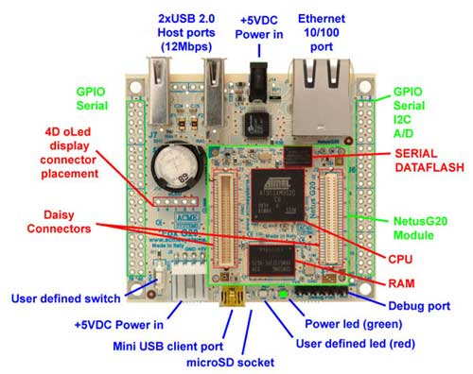
Two 40 pin sockets pitch 2.54 mm are available to plug the board on specific application carriers or add-on boards. On these pins 3.3 Volt signals are available which can be used to implement RS232/RS485/RS422, I2C, SPI, GPIO, A/D and PWM interfaces.
A fast prototyping cabling system is also available to realize your end-user devices without using the soldering iron or designing any custom board.
- Built on the Atmel ARM9 @ 400Mhz CPU module Netus G20-L (included)
- 256KB of FLASH memory for the bootloader
- Up to 16GB on bootable microSD (*)
- Two USB 2.0 host ports (12 Mbits)
- One Ethernet 10/100 port
- One USB device port (12 Mbits)
- One debug serial port (3.3v)
- Two serial ports (3.3v)
- One serial port for 4DSystems oLed displays
- 5VDC power supply input (compatible with PS5V1A)
- Real Time Clock with on-board backup battery (**)
- GPIO lines (3.3v)
- 4 A/D converter lines, I2C bus, SPI bus
- Built-in quad power supply Netus PS1 module
- Same footprint and pinout of the old FOX Board LX832
- Fully mechanical compatible with TUXCASE and FOXCASE
- Average power consumpiom: 80 mA @ 5V (0.4 Watt) without microSD, ethernet link, USB devices or other peripherals.
- Operative temperature range: 0° + 70°
(*) the microSD card memory is optional
(**) the lithium backup battery for RTC is optional
Netus G20

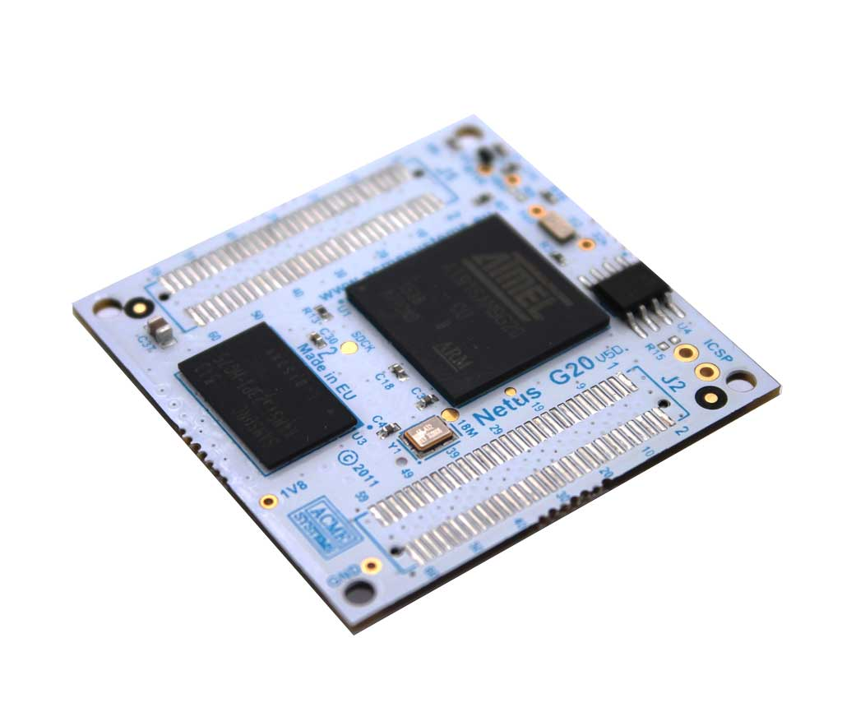
- CPU Atmel AT91SAM9G20 based on ARM926EJ-S - ARM ® Thumb ® Processor with an internal clock speed of 400MHz
- 64MBytes of SDRAM with 32bit parallel access
- 256KB of data flash (NETUSG20-L)
- Size 40x40mm. Weight 10g
- Operative temperature range: -20° + 70°
- Four 60 pin connectors (0.8mm pitch) with the following signals available both on top and bottom sides (see the pinout)
  - One USB 2.0 (12 Mbits per second) Device Port
  - Two USB 2.0 (12 Mbits per second) Host Ports
  - One Ethernet MAC 10/100 Base T Port
  - Image Sensor Interface (ITU-R BT. 601/656 12 bit)
  - One Two-slot MultiMedia Card Interface (MCI). SDCard/SDIO and MultiMediaCard Compliant
  - Four Universal Synchronous/Asynchronous Receiver Transmitters (USART) with RS485 support
  - Two 2-wire UARTs
  - Two Master/Slave Serial Peripheral Interfaces (SPI)
  - One Synchronous Serial Controller (SSC). I2S Analog Interface Support
  - Two Wire Interface
  - Four-channel 10-bit ADC
  - 80 general purpose I/O lines multiplexed with up to two peripheral I/Os
  - Individually Programmable Open-drain, Pull-up Resistor and Synchronous Output
  - All I/O Lines are Schmitt Trigger when programmed as inputs
  - Input Change Interrupt Capability on Each I/O Line
  - Serial 2 wire console port
  - JTAG Console and Boundary Scan on All Digital Pins (IEEE ® 1149.1)
- Two Three-channel 16-bit Timer/Counters with PWM Generation
- Watchdog timer
- Real-time clock (optional external battery backup)
- Very Slow Clock Operating Mode

Architecture interne du SAM G20

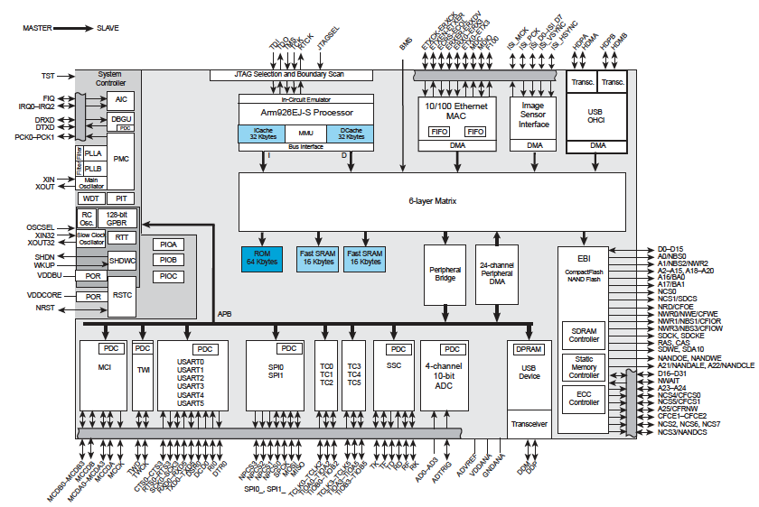

Pin # | ID | I/O line | Alt | Description | Pin # | ID | Line | Alt | Description
J7.1 |  | GND |  | Signal ground | J6.1 |  | 3.3V |  | 3.3 volt DC power line
J7.2 |  | GND |  | Signal ground | J6.2 |  | 3,3V |  | 3.3 volt DC power line
J7.3 | 50 | PB18 |  | General purpose I/O | J6.3 | 60 | PB28 | RTS1 | Request to send ttyS2
J7.4 | 51 | PB19 |  | General purpose I/O | J6.4 | 39 | PB7 | RXD1 | Receive data ttyS2
J7.5 | 48 | PB16 |  | General purpose I/O | J6.5 | 38 | PB6 | TXD1 | Transmit line ttyS2
J7.6 | 49 | PB17 |  | General purpose I/O | J6.6 | 61 | PB29 | CTS1 | Clear to send ttyS2
J7.7 | 34 | PB2 |  | General purpose I/O | J6.7 | 58 | PB26 | RTS0 | Request to send ttyS1
J7.8 | 35 | PB3 |  | General purpose I/O | J6.8 | 37 | PB5 | RXD0 | Receive data ttyS1
J7.9 | 32 | PB0 |  | General purpose I/O | J6.9 | 36 | PB4 | TXD0 | Transmit data ttyS1
J7.10 | 33 | PB1 |  | General purpose I/O | J6.10 | 52 | PB27 | CTS0 | Clear to send ttyS1
J7.11 | 78 | PC14 |  | General purpose I/O 1.8V | J6.11 |  |  |  | N.C. (See the schematic)
J7.12 | 79 | PC15 |  | General purpose I/O 1.8V | J6.12 |  | 5V |  | 5 volt DC power live
J7.13 | 76 | PC12 |  | General purpose I/O 1.8V | J6.13 | 43 | PB11 | RXD3 | Receive data ttyS4
J7.14 | 77 | PC13 |  | General purpose I/O 1.8V | J6.14 | 42 | PB10 | TXD3 | Transmit data ttyS4
J7.15 | 73 | PC9 |  | General purpose I/O 1.8V | J6.15 | 45 | PB13 | RXD5 | Receive data ttyS6
J7.16 | 74 | PC10 | CTS3 | Clear to send ttyS4 1.8V | J6.16 | 44 | PB12 | TXD5 | Transmit data ttyS6
J7.17 | 71 | PC7 |  | Red led line 1.8V | J6.17 | 53 | PB21 |  | General purpose I/O
J7.18 | 72 | PC8 | RTS3 | Request to send ttyS4 1.8V | J6.18 | 52 | PB20 |  | General purpose I/O
J7.19 | 69 | PC5 |  | General purpose I/O 1.8V | J6.19 | 63 | PB31 |  | General purpose I/O
J7.20 | 70 | PC6 |  | Reserved line. Used to read if the client USB port is wired to a PC | J6.20 | 62 | PB30 |  | General purpose I/O
J7.21 | 41 | PB9 | RXD2 | Receive data ttyS3 | J6.21 | 31 | PA31 | TXD4 | Transmit data ttyS5
J7.22 | 40 | PB8 | TXD2 | Transmit data ttyS3 | J6.22 | 30 | PA30 | RXD4 | Receive data ttyS5
J7.23 |  | BATT |  | RTC Battery input | J6.23 |  |  |  | N.C. (See the schematic)
J7.24 |  | PGD |  | Power good NetusPS1 | J6.24 | 6 | PA6 |  | General purpose I/O
J7.25 |  | POK |  | 3.3V NetusPS1 aux output stable | J6.25 | 7 | PA7 |  | General purpose I/O
J7.26 |  | SHDNPS# |  | PS1 shutdown. Active low | J6.26 | 9 | PA9 |  | General purpose I/O
J7.27 |  | NRST |  | Reset output | J6.27 | 67 | PC3 | AD3 | Analog input 3
J7.28 |  | SHDN# |  | Turn off the CPU when low | J6.28 | 66 | PC2 | AD2 | Analog input 2
J7.29 |  | 5V |  | 5 volt power line | J6.29 | 65 | PC1 | AD1 | Analog input 1
J7.30 |  | WAKEUP |  | Wake up input | J6.30 | 64 | PC0 | AD0 | Analog input 0
J7.31 | 55 | PB23 | DCD0 | Data carrier detect ttyS1 | J6.31 | 24 | PA24 | SCL | I2C Clock
J7.32 | 54 | PB22 | DSR0 | Data set ready ttyS1 | J6.32 | 23 | PA23 | SDA | I2C Data
J7.33 | 57 | PB25 | RI0 | Ring indicator ttyS1 | J6.33 |  | AVDD |  | Clean 3.3V out for A/D circuitry
J7.34 | 56 | PB24 | DTR0 | Data terminal ready ttyS1 | J6.34 |  | VREF |  | A/D voltage reference input
J7.35 | 28 | PA28 |  | General purpose I/O | J6.35 |  | AGND |  | Analog ground
J7.36 | 27 | PA27 |  | General purpose I/O | J6.36 | 10 | PA10 |  | General purpose I/O
J7.37 | 26 | PA26 |  | General purpose I/O | J6.37 | 22 | PA22 |  | General purpose I/O
J7.38 | 25 | PA25 |  | General purpose I/O | J6.38 | 11 | PA11 |  | General purpose I/O
J7.39 |  | 3.3V |  | 3.3 volt power line | J6.39 |  | GND |  | Signal ground
J7.40 |  | 3.3V |  | 3.3 volt power line | J6.40 |  | GND |  | Signal ground

